Jegyzőkönyv Háttéralkalmazások 1. gyakorlat

# 3. feladat:

1. 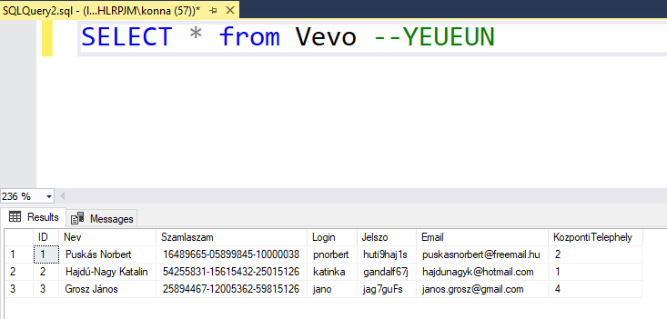

SELECT * from Vevo –YEUEUN

2. 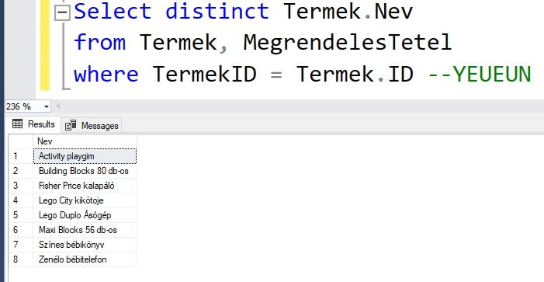

Select distinct Termek.Nev

from Termek, MegrendelesTetel

where TermekID = Termek.ID –YEUEUN

3. 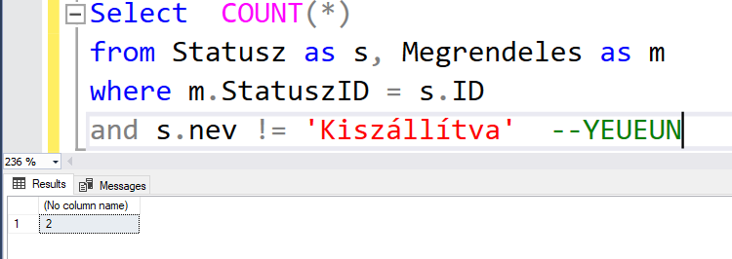

Select COUNT(*)

from Statusz as s, Megrendeles as m

where m.StatuszID = s.ID

and s.nev != 'Kiszállítva' --YEUEUN

4. 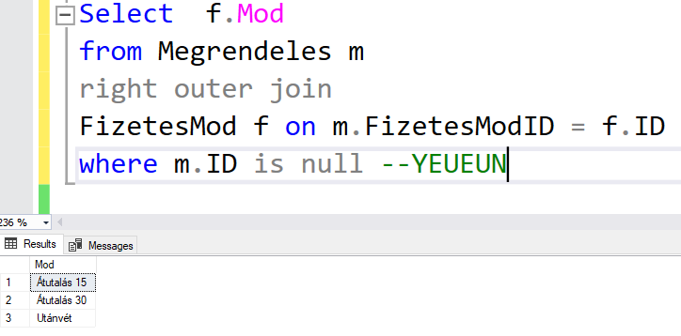

Select f.Mod

from Megrendeles m

right outer join

FizetesMod f on m.FizetesModID = f.ID

where m.ID is null –YEUEUN

5. 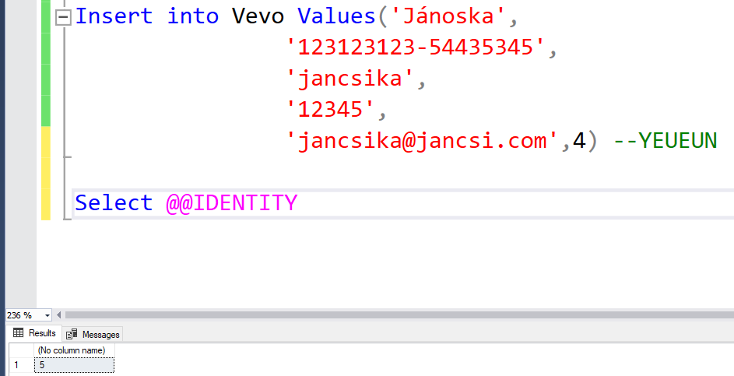

Insert into Vevo Values('Jánoska',

'123123123-54435345',

'jancsika',

'12345',

'jancsika@jancsi.com',4) --YEUEUN

Select @@IDENTITY

6. 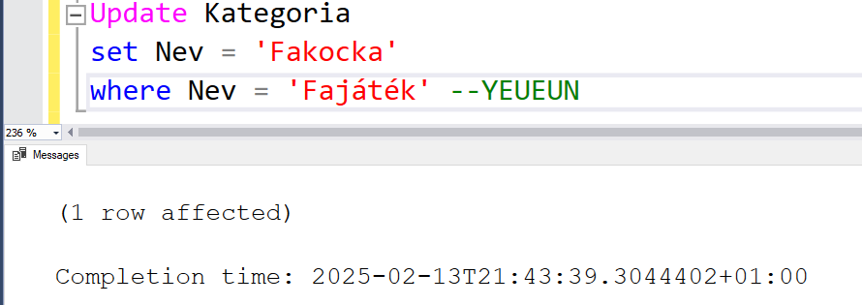

Update Kategoria

set Nev = 'Fakocka'

where Nev = 'Fajáték' –YEUEUN

7. 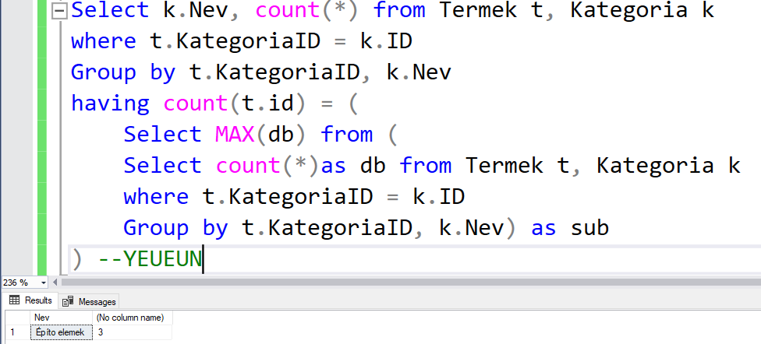

Select k.Nev, count(*) from Termek t, Kategoria k

where t.KategoriaID = k.ID

Group by t.KategoriaID, k.Nev

having count(t.id) = (

Select MAX(db) from (

Select count(*)as db from Termek t, Kategoria k

where t.KategoriaID = k.ID

Group by t.KategoriaID, k.Nev) as sub

) –YEUEUN

# 4.Feladat önálló

1. 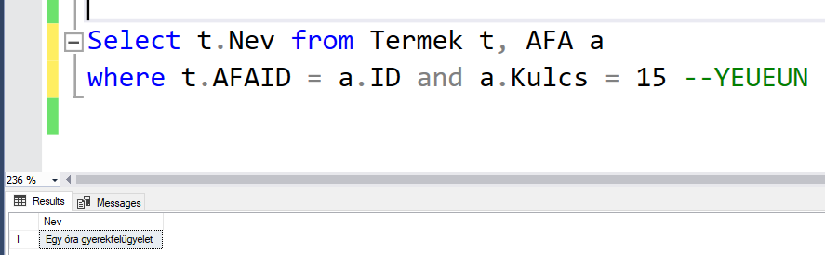

Select t.Nev from Termek t, AFA a

where t.AFAID = a.ID and a.Kulcs = 15 –YEUEUN

2. 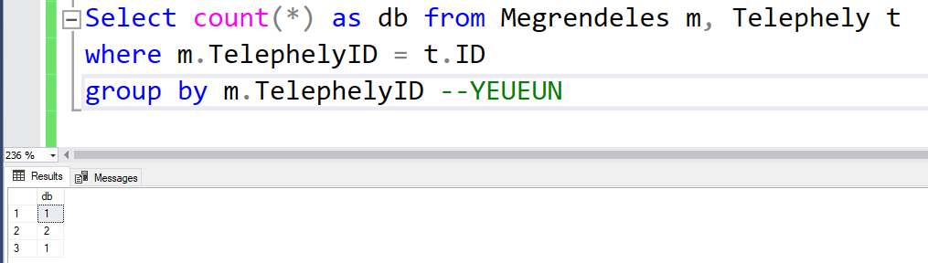

Select count(*) as db from Megrendeles m, Telephely t

where m.TelephelyID = t.ID

group by m.TelephelyID –YEUEUN

3. 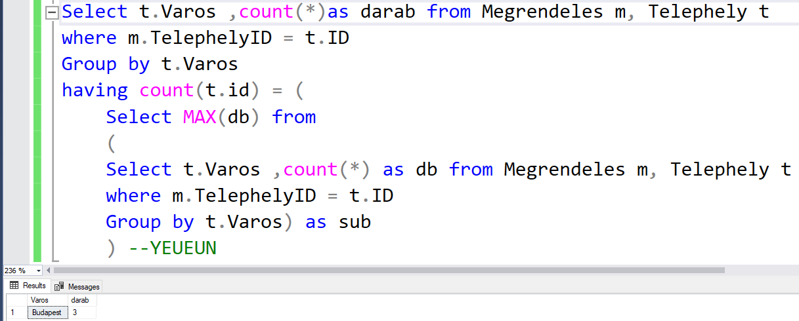

Select t.Varos ,count(*)as darab from Megrendeles m, Telephely t

where m.TelephelyID = t.ID

Group by t.Varos

having count(t.id) = (

Select MAX(db) from

(

Select t.Varos ,count(*) as db from Megrendeles m, Telephely t

where m.TelephelyID = t.ID

Group by t.Varos) as sub

) –YEUEUN

4. 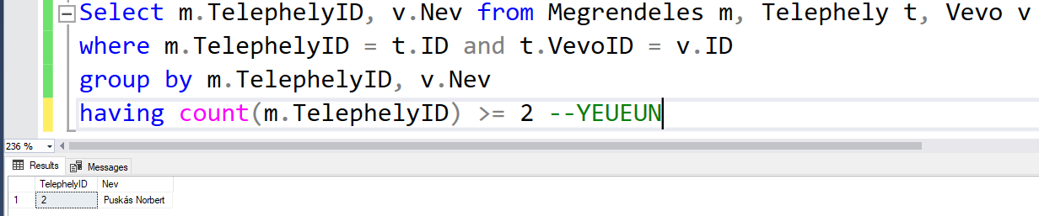

Select m.TelephelyID, v.Nev from Megrendeles m, Telephely t, Vevo v

where m.TelephelyID = t.ID and t.VevoID = v.ID

group by m.TelephelyID, v.Nev

having count(m.TelephelyID) >= 2 –YEUEUN

5. 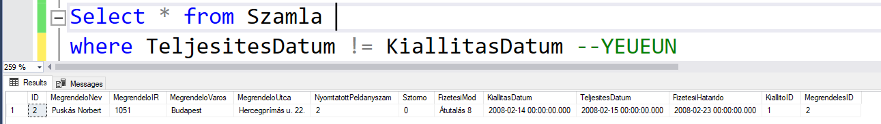

Select * from Szamla

where TeljesitesDatum != KiallitasDatum –YEUEUN

6. 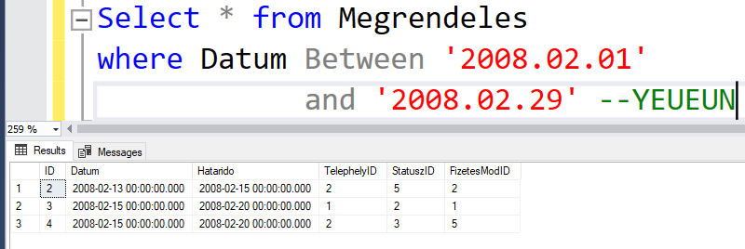

Select * from Megrendeles

where Datum Between '2008.02.01'

and '2008.02.29' –YEUEUN

7. 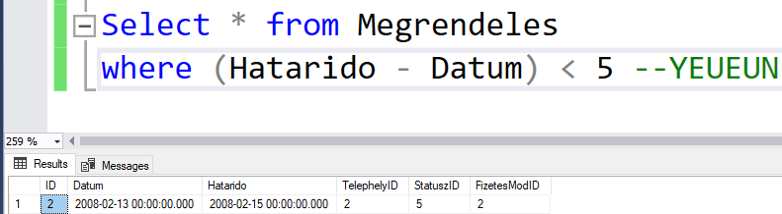

Select * from Megrendeles

where (Hatarido - Datum) < 5 –YEUEUN

8. 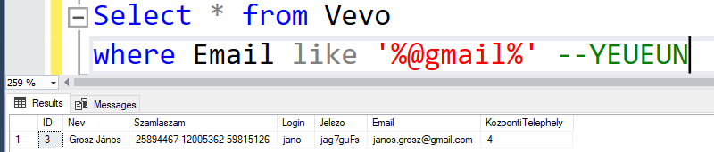

Select * from Vevo

where Email like '%@gmail%' --YEUEUN

9. 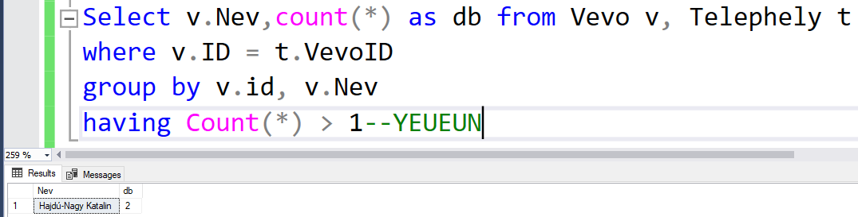

Select v.Nev,count(*) as db from Vevo v, Telephely t

where v.ID = t.VevoID

group by v.id, v.Nev

having Count(*) > 1—YEUEUN

10. 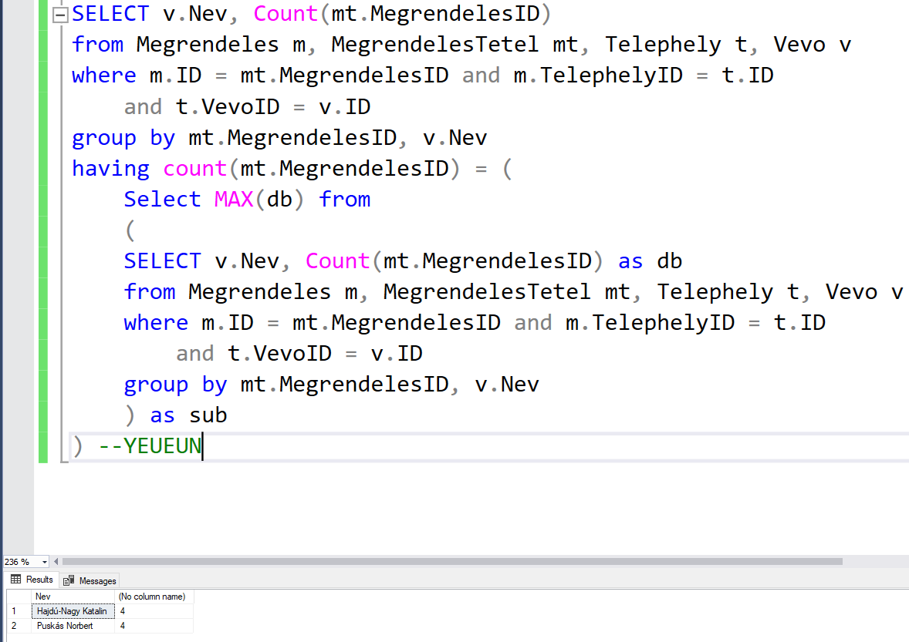

SELECT v.Nev, Count(mt.MegrendelesID)

from Megrendeles m, MegrendelesTetel mt, Telephely t, Vevo v

where m.ID = mt.MegrendelesID and m.TelephelyID = t.ID

and t.VevoID = v.ID

group by mt.MegrendelesID, v.Nev

having count(mt.MegrendelesID) = (

Select MAX(db) from

(

SELECT v.Nev, Count(mt.MegrendelesID) as db

from Megrendeles m, MegrendelesTetel mt, Telephely t, Vevo v

where m.ID = mt.MegrendelesID and m.TelephelyID = t.ID

and t.VevoID = v.ID

group by mt.MegrendelesID, v.Nev

) as sub

) --YEUEUN